“Smart Delivery Route Optimizer with Dynamic Order Closure”
Srimathimurugesan¹, Rashikajesu², Sathyamoorthypughazhendi³,
Vishnupriyaganesan⁴, Ulageshwarannehru⁵, Vigneshwarpalani⁶
ABSTRACT:
This project proposes a mobile application that intelligently arranges delivery orders in an optimized sequence using Google Maps API [1] and AI algorithms [2]. Unlike existing systems, it includes a dynamic closure mechanism where each delivery location is marked as completed once the order is delivered. The system then updates the route for remaining stops, ensuring time, fuel, and cost efficiency. The app is designed for logistics, food delivery, courier, and e-commerce industries.
KEYWORDS:
Route Optimization, Dynamic Order Closure, Smart Delivery System, Traveling Salesman Problem (TSP), Real-time GPS Tracking.

1.INTRODUCTION
In today’s fast-paced world, efficient delivery systems have become the backbone of industries such as e-commerce, logistics, food services, and healthcare. Customers expect faster, more reliable, and transparent delivery experiences, while companies strive to minimize operational costs, fuel consumption, and delivery times. Traditional delivery management systems often follow static routes that do not adapt to real-time changes, leading to inefficiencies such as delayed deliveries, higher fuel expenses, and poor resource utilization. The Smart Delivery Route Optimizer App [3] with Dynamic Location Closure addresses these challenges by combining route optimization algorithms, GPS navigation, and real-time dynamic updates. Unlike conventional systems, this application automatically recalculates and updates the delivery route whenever a stop is completed, ensuring that drivers always follow the most efficient path for the remaining deliveries. With integrated Google Maps APIs and AI-driven algorithms, the app not only optimizes routes but also considers traffic data and live conditions to provide accurate ETAs. Furthermore, the system introduces a dynamic closure mechanism that marks each location as delivered, reducing redundancy and simplifying the delivery process. Features such as proof-of-delivery, traffic-aware navigation, and analytics dashboards enhance reliability and transparency for both customers and managers. By improving efficiency, reducing costs, and promoting eco-friendly operations, this project contributes significantly to the growing need for smarter logistics solutions [4].

2.OBJECTIVES
- To optimize delivery routes with multiple locations.
- To dynamically update the route when a delivery is completed.
- To reduce fuel consumption and delivery time.
- To integrate GPS and traffic data for real-time decision-making.
- To provide proof-of-delivery and automatic order closure.

3.METHODOLOGY
- Order Collection: Driver receives orders with delivery addresses.
- Geocoding: Convert addresses to latitude/longitude.
- Optimization: Apply shortest route algorithms (e.g., Dijkstra, Genetic Algorithm, or Google OR-Tools for TSP).
- Navigation: Display optimized path with directions.
- Delivery Closure: Once delivery is done → driver presses “Delivered”, order is closed.
- Dynamic Update: Remaining route is recalculated.
- Completion Report: Total distance, time, and fuel saved are generated.

4.SYSTEM ARCHITECTURE
- Frontend (Mobile App): Flutter / React Native
- Backend: Node.js or Django + Firebase
- Database: Firebase / MySQL (order details, delivery status)
- APIs: Google Maps API, Distance Matrix API
- AI/ML: Python (OR-Tools, TSP solvers, route prediction)

5.FLOWCHART
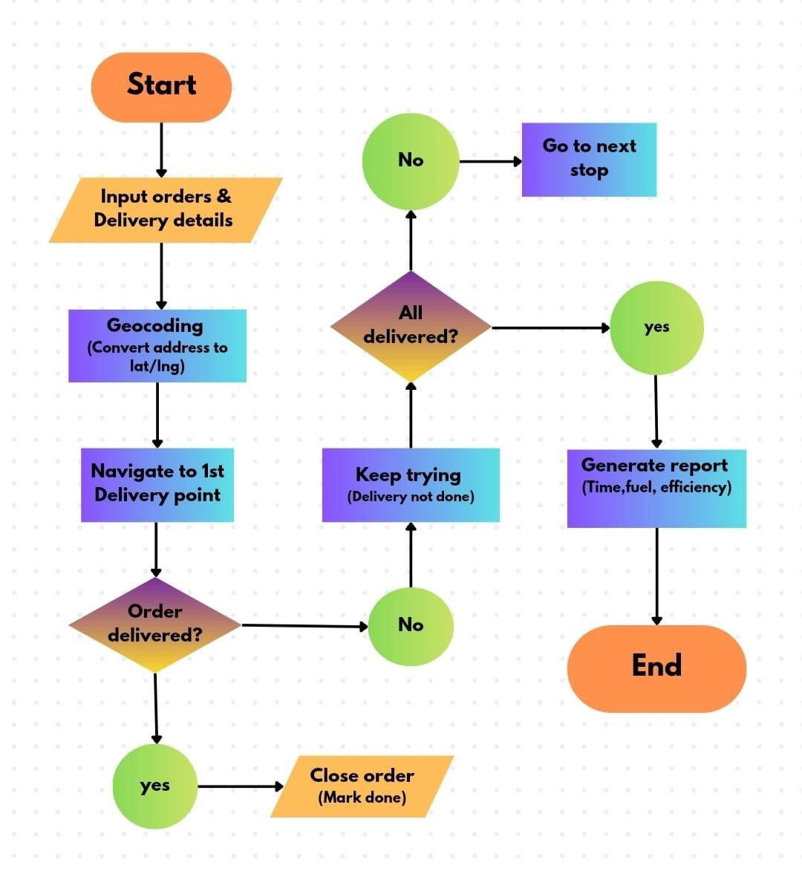

6.FEATURES
- Multi-order input & optimization
- Dynamic closure of delivered locations
- Proof of delivery (photo/OTP/signature)
- Live GPS tracking & ETA updates
- Traffic-aware re-routing
- Analytics dashboard for managers

7.ADVANTAGES
- Reduces time, cost, and fuel consumption.
- Makes deliveries efficient and eco-friendly.
- Improves customer satisfaction with accurate ETA.
- Can scale for e-commerce, food, courier, medicine deliveries.

8.FUTURE SCOPE
- AI-based demand prediction and auto-assign routes.
- Integration with drones or autonomous vehicles.
- Blockchain for secure proof-of-delivery.
- Offline mode for areas without internet.

9.ACKNOWLEDGEMENT
I would like to express my sincere gratitude to Loyola institute of technology for providing the necessary resources and support for this research. My heartfelt thanks go to my friends for their valuable guidance, encouragement, and insightful contributions throughout this study. I also extend my deep appreciation to Dr. M.G.R university and Nirmal Kumar, and M. GUNASRI for their support, expert advice, and constructive feedback, which played a crucial role in shaping this research. Lastly, I am grateful to my family, friends, and colleagues for their unwavering support and motivation during this journey.

10.CONCLUSION
The Smart Delivery Route Optimizer App with Dynamic Location [5] Closure provides an innovative solution to one of the most critical challenges in modern logistics—efficient route planning and dynamic adaptation. By integrating Google Maps APIs, AI-based optimization algorithms, and realtime GPS tracking, the system ensures faster deliveries, reduced fuel consumption, and improved customer satisfaction. Unlike traditional delivery systems, the inclusion of a dynamic closure mechanism makes the solution more adaptive, reliable, and user-friendly. This project demonstrates how technology can significantly enhance the efficiency of logistics, food delivery, courier, and ecommerce industries. With features such as proof-of-delivery, traffic-aware re-routing, and detailed analytics, the proposed system creates a balance between operational efficiency and customer convenience. Overall, this project represents a step toward smart, sustainable, and future-ready delivery management systems.

11.REFRENCE
- L. Vanajakshi and L. R. Rilett, “Support vector machine technique for the short-term prediction of travel time,” IEEE Transactions on Intelligent Transportation Systems, vol. 7, no. 2, pp. 187–202, 2007.
- P. Raj and A. Raman, Building Smart Applications using AI and Machine Learning. Birmingham, UK: Packt Publishing, 2017.
- A. Sillitti and G. Succi, Mobile App Development: A Practical Approach for Beginners. Cham, Switzerland: Springer, 2016.
- J. F. Ehmke and A. M. Campbell, “Customer acceptance mechanisms for home deliveries in attended delivery networks,” Transportation Science, vol. 48, no. 4, pp. 547–564, 2014.
- H. N. Psaraftis, M. Wen, and C. A. Kontovas, “Dynamic vehicle routing problems: Three decades and counting,” Networks, vol. 67, no. 1, pp. 3–31, 2016.

